Visual Accessibility Guide – For groups and individuals with additional needs
1 - Entry to the building
You will enter the building through the doors on the left of the building. We do not use the revolving doors at the moment. The building looks large, it used to be an RAF aircraft hangar.
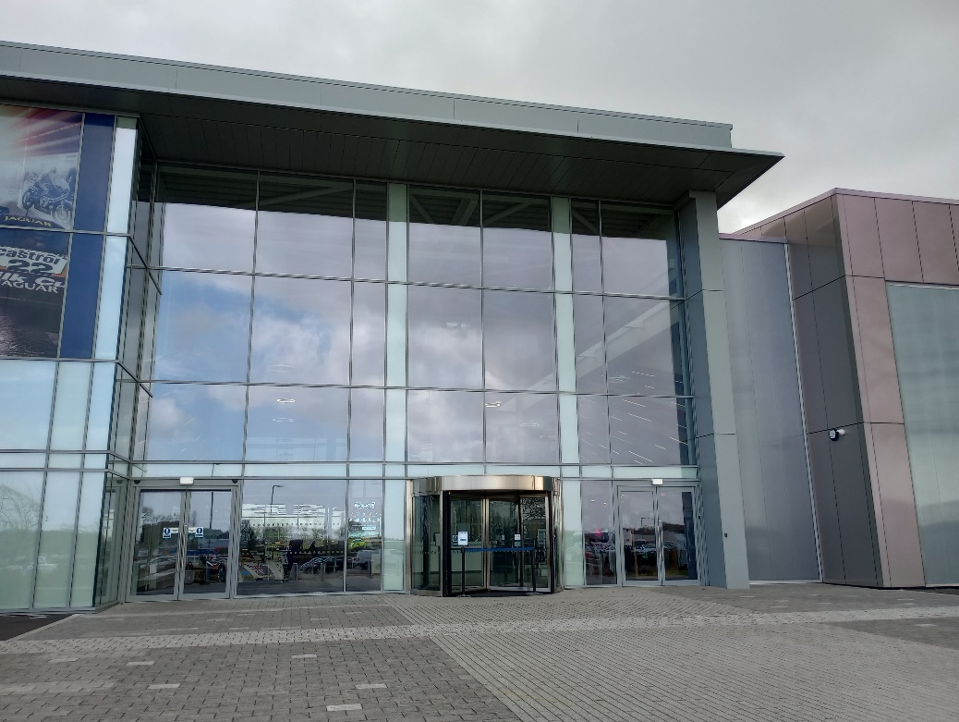
Once you are into the building you will collect your tickets from the ticket desk. There is a Formula One car hanging above you, don’t worry it is VERY secure. You will then head up the stairs into the Museum. A lift is available to the left of the stairs, before the café.
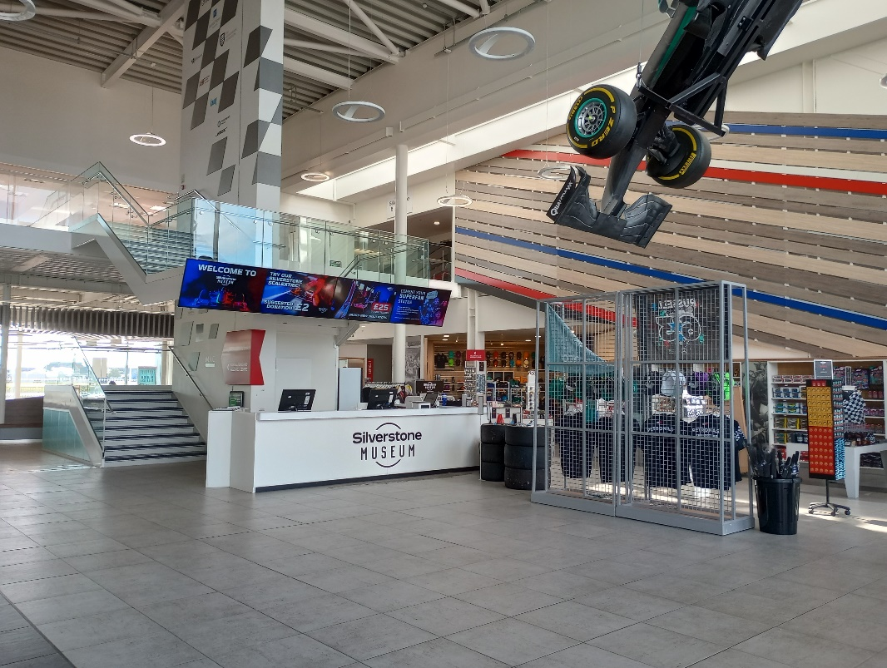

2 – Join the Grid
To enter the exhibition, you experience the Grid. This will be a journey through Silverstone’s motor racing history. This will be exciting and build anticipation for what is to come. This is a technologically advanced media show that you can enjoy. The show time is approximately 4 minutes.
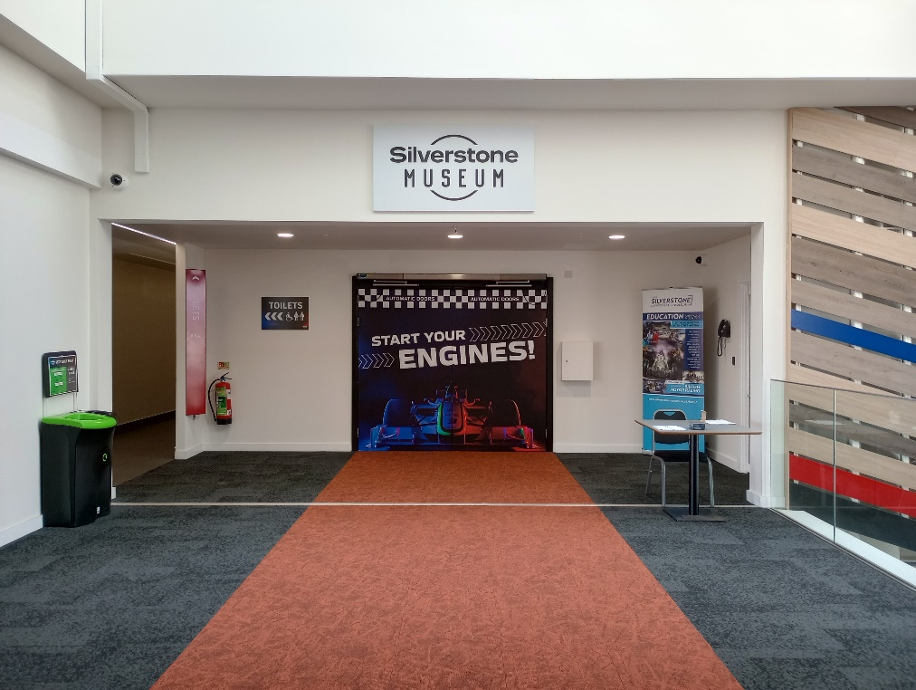
The Grid is loud and there are bright moving images. There is darkness for a few seconds after the countdown, the screens are still shining light so it is not completely dark. There is a door to exit the Grid after entering if you choose to. There is an option for visitors to walk past this phase of the exhibition. Please ask one of the welcome team to direct you to this. We also have ear plugs that you can use here if you would like them.

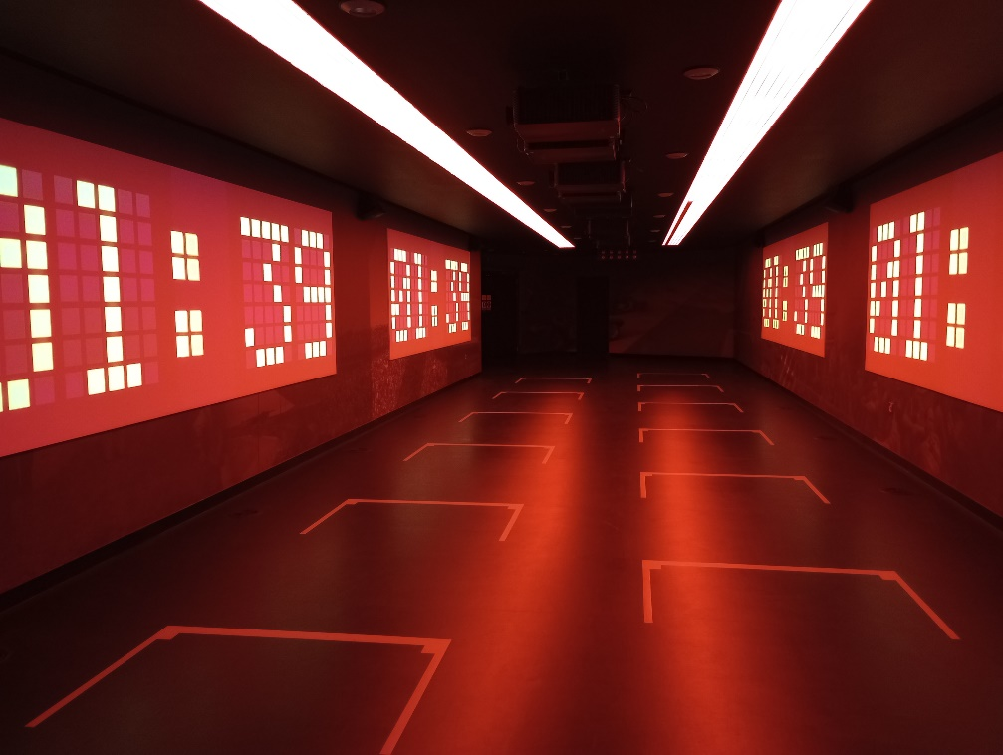
3 – History at every Turn
As you leave the Grid you walk through the opening part of Silverstone Museum. There are patches of light and darkness in this area. You will learn all the names and the history behind the corners of the circuit and find out how Silverstone Circuit became the home of British motor sport. There are links to History in all these sections.
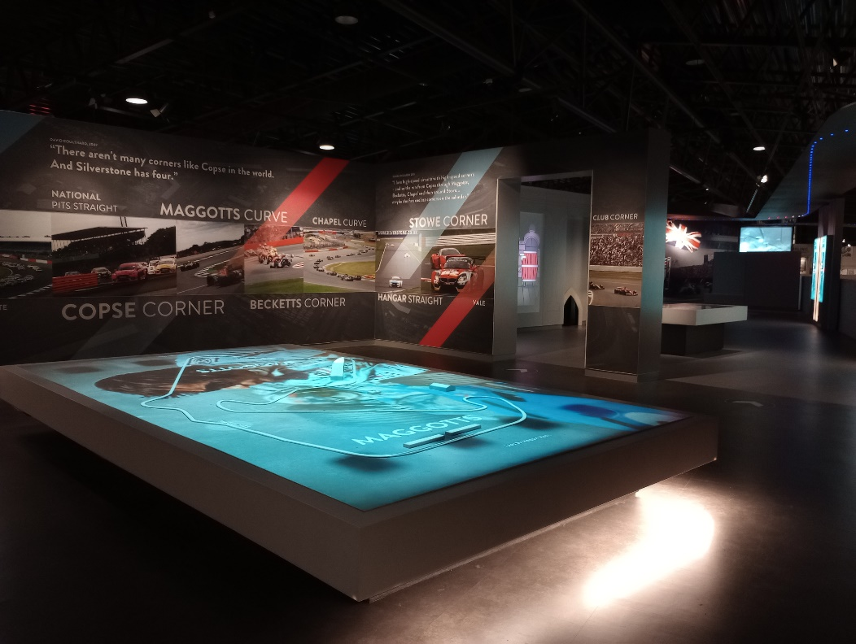

You can crawl through the tunnel and explore what’s hidden inside. There are many interactive elements in this section that you will be able to experience. It can sometimes be a bit noisy here as some visitors get a bit excited.
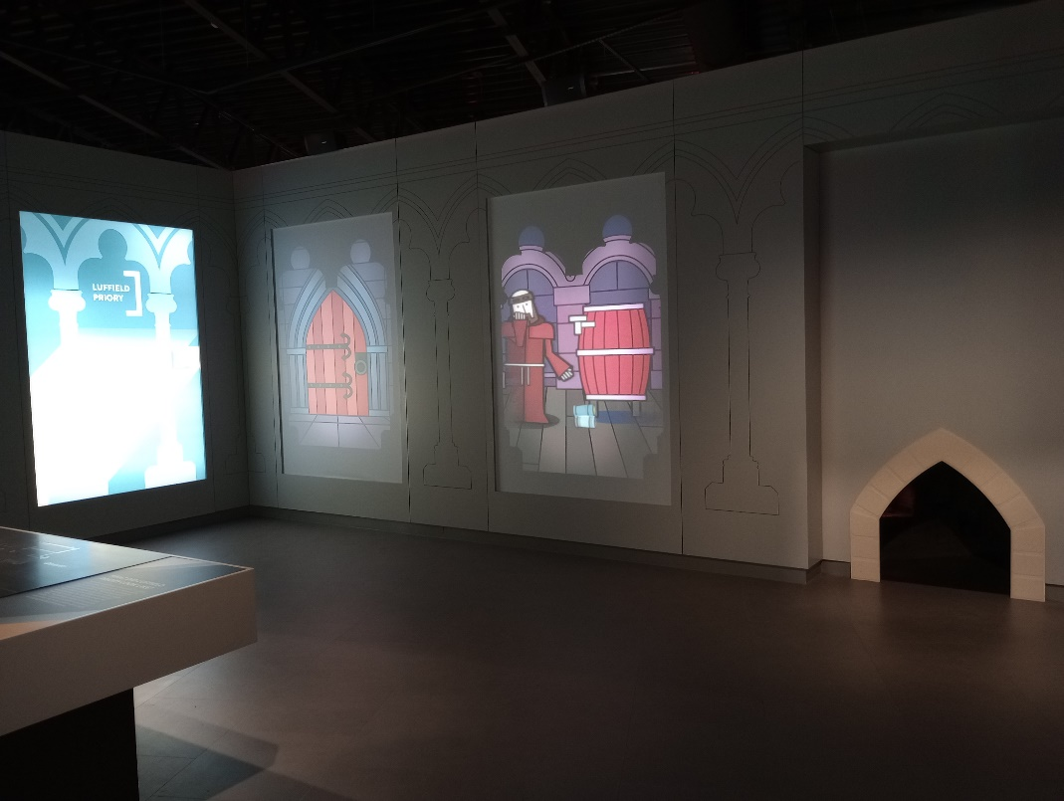
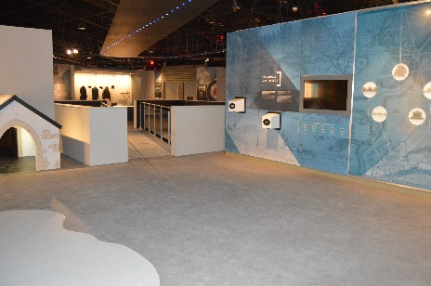
4 – RAF Silverstone
Discover Silverstone’s past as a Bomber Command Training base during the Second World War.
This is where you will find out about the men and women who were stationed at Silverstone during the war, see their real uniforms and understand how pilots learnt to fly Wellington bombers. There are three different hands-on activities including practicing to shoot barrage balloons and having a go on the Link Trainer - a replica of the machine the RAF used to train pilots.
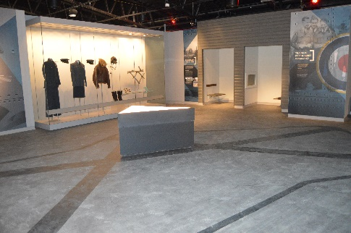
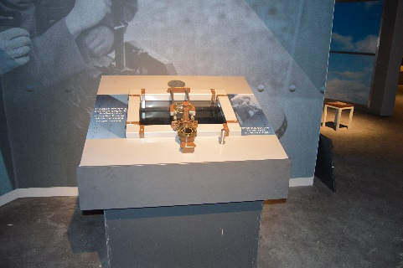

A memorial to commemorate the fallen is also in this section. We ask that visitors are quiet here as a mark of respect.
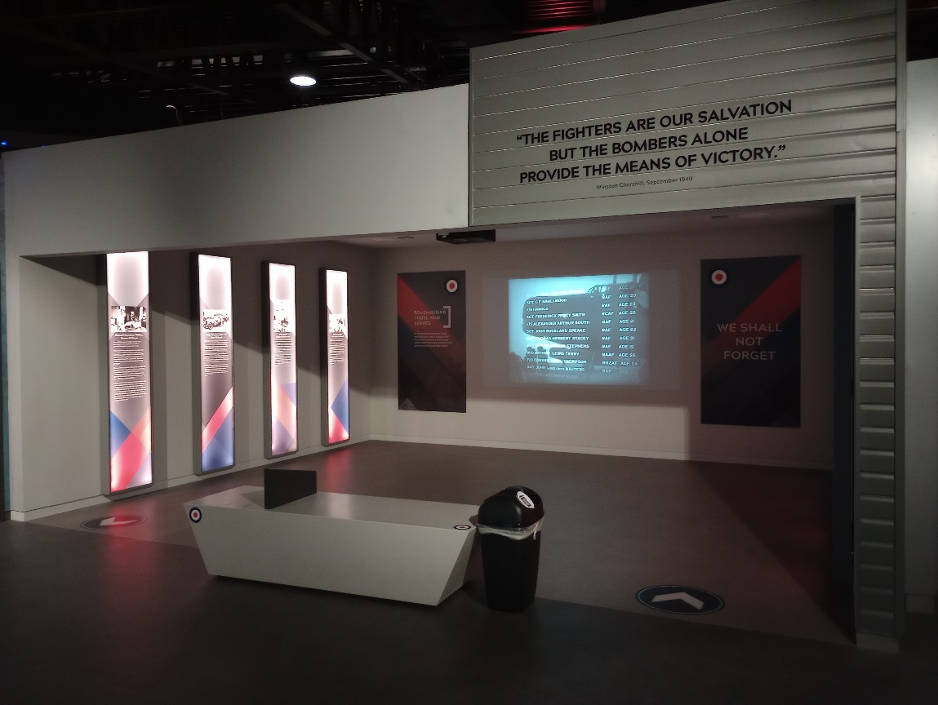

5 – Village & Farm
Find out all about the village that gave the country’s most famous racing circuit its name and learn about the area around the track. Farmers worked the fields even after racing had begun in the late 1940s and some unlucky drivers and riders ended up amongst the crops!
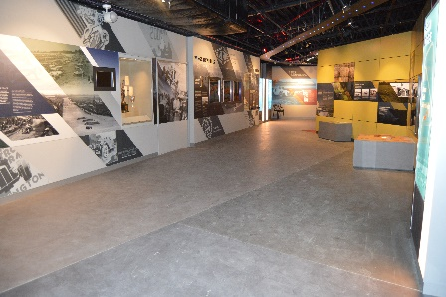
You can play games in the pub, sit on the stools there and set up a car to race against a competitor.
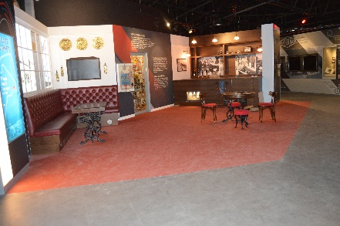

6 – Wings to Wheels
Silverstone's wide, open space and runways would prove to be the perfect location for what would become one of the most famous racetracks in the world. Find out the story of how a group of drivers snuck onto the old airfield and how the use of Silverstone as a race circuit led to the first Grand Prix, in 1948 – there are some great fun stories here. There are touch screens here and make a brass rubbing image. You may sit inside the replica ERA car here and have your photo taken.
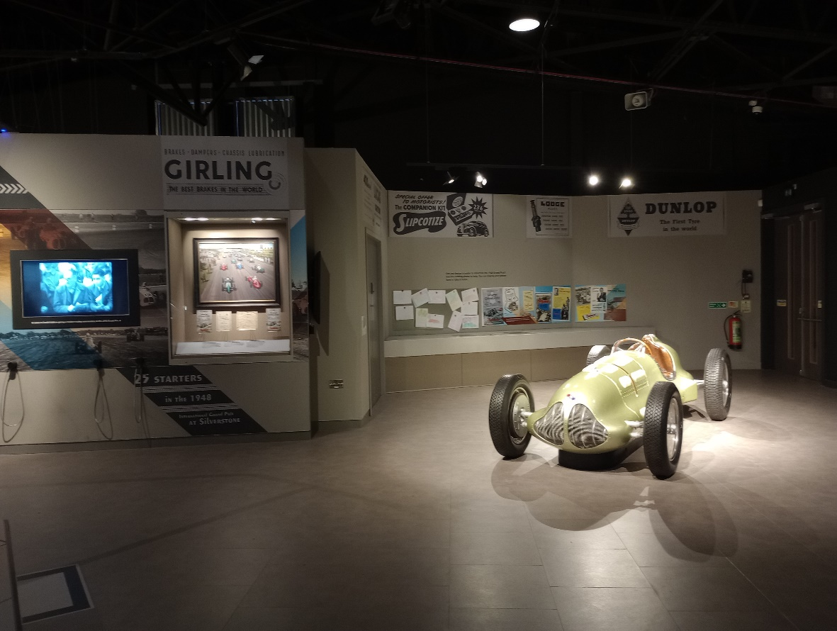

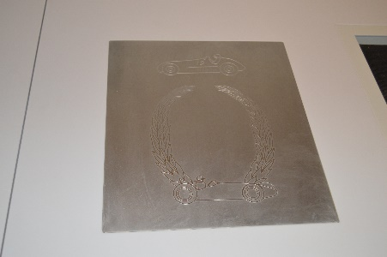
7 – Heart of Silverstone
After leaving the village, take a journey down the staircase and through the heart of Silverstone. Feel the excitement build as you see, hear and smell the atmosphere of race day at the track.
As visitors move downstairs there is imagery that will build excitement, advise young people that they should move slowly and sensibly on the stairs and absorb the atmosphere. There is a glass elevator for those who need this facility.
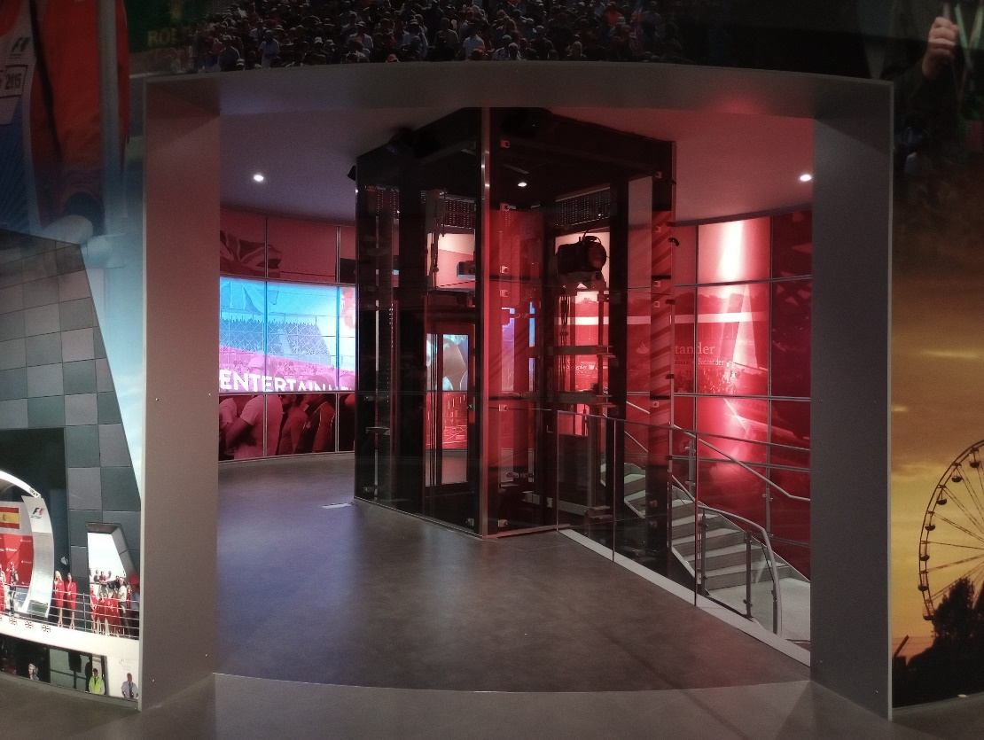
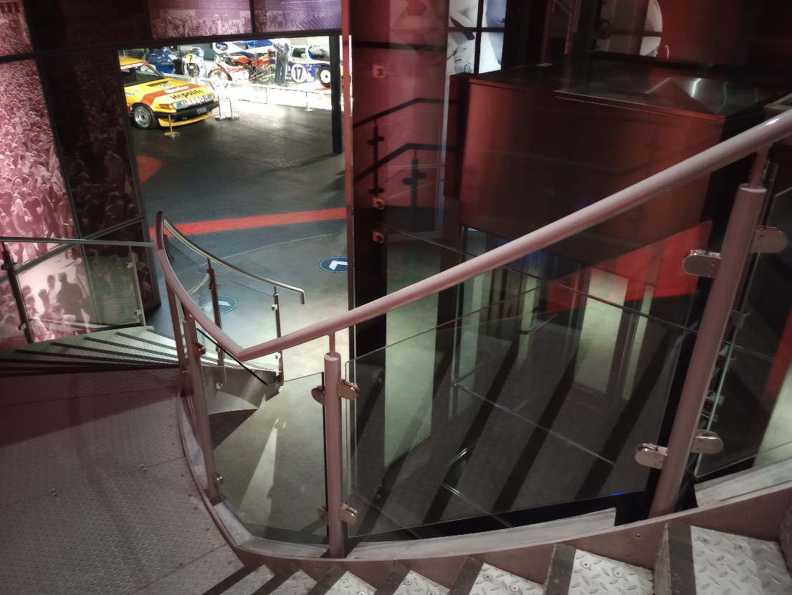

8 – Race Day Explained
You can walk up to the replica pit wall and get close to amazing racing cars and a support vehicle with several interactive elements here.
It's time to learn about the huge effort that goes into putting on a race. From race marshals to the medical centre, hear first-hand accounts of what is needed to run a busy race day.
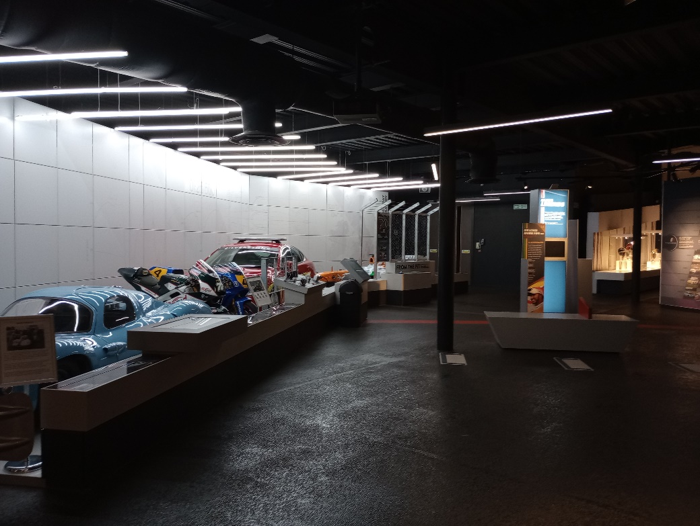

There is plenty of interactivity in this section. There are screens to touch and a Pit Gun for you to time a tyre change.
Behind the pit lane you can learn about the media who are involved in a race weekend and try your best at being a commentator.
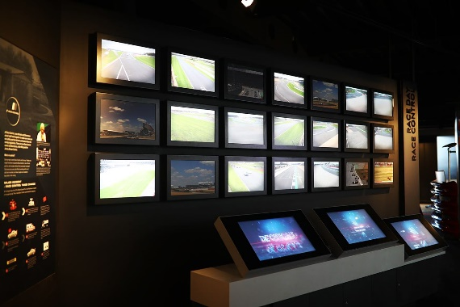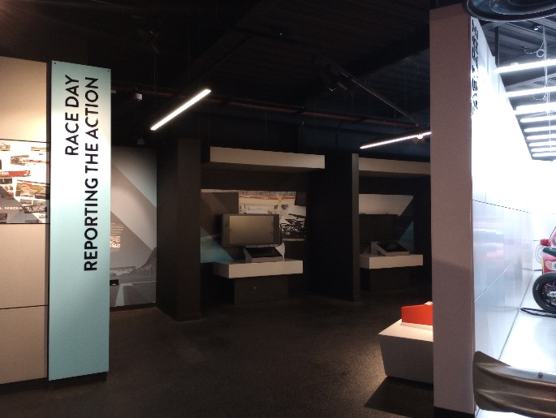

9 – Tech Lab
In Tech Lab you can explore all the key aspects of the science and engineering that goes into the design and build of a racing car and motorbike.
With the help of experts from McLaren and Suzuki, visitors can learn about the incredible technology that goes into racing and test your knowledge on a series of interactive challenges. This section has lots to touch and feel from tyres and materials, to screens and interactives.
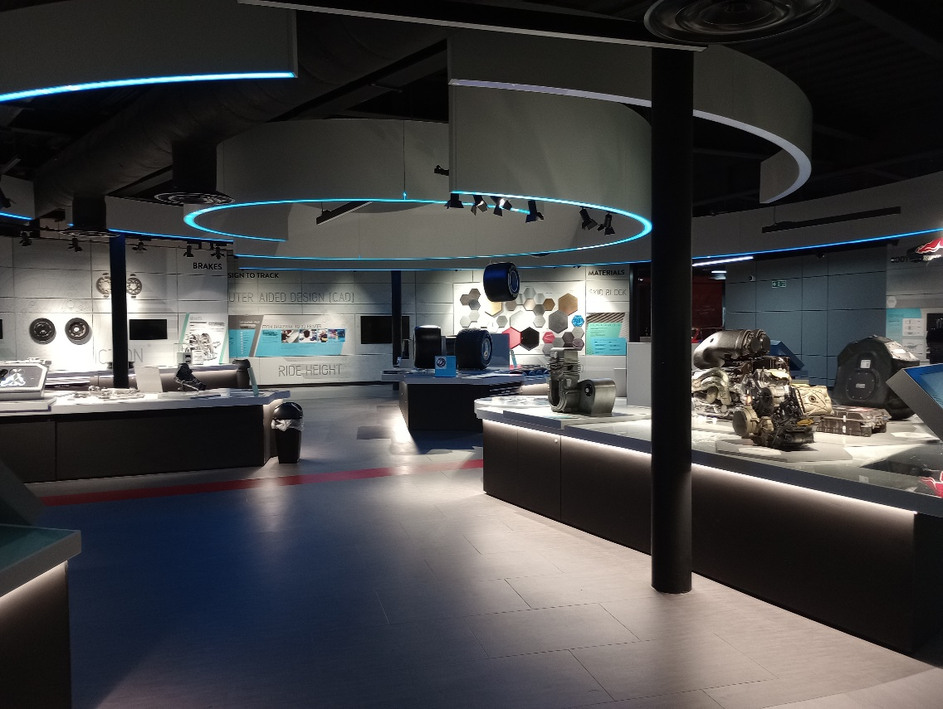
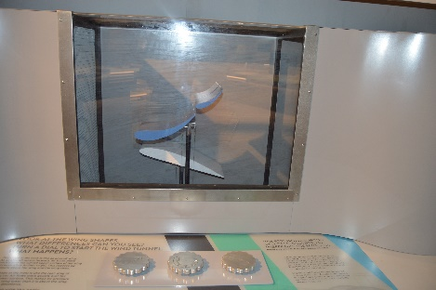

10 - Racing Eras
It is here that you can look at some of the most significant cars and motorcycles to have raced at Silverstone, from sports car and touring car classics to iconic MotoGP and Formula 1 machines. From time to time we are lucky to have new cars, bikes and racing items in the museum. This means that some of the items in the pictures may change, or the vehicles may not be displayed on a plinth. Please be careful where you walk and do not touch if this is the case.
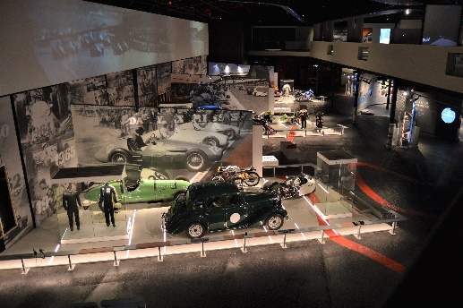
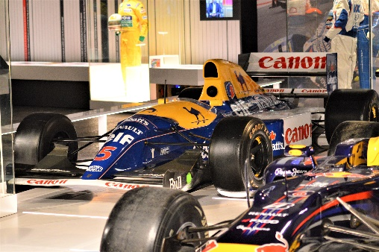

10 – Simulators
Racing simulators can be booked at extra cost. You can do this before or during your visit. If you are taking part in this exciting activity a member of staff will meet you at the ticket desk and guide you to the simulator room. They will explain to you how the machine works. If you need any additional assistance at this time, please ask. There is a height restriction in place, all those who drive the simulator must be over 1 meter 40cm tall.
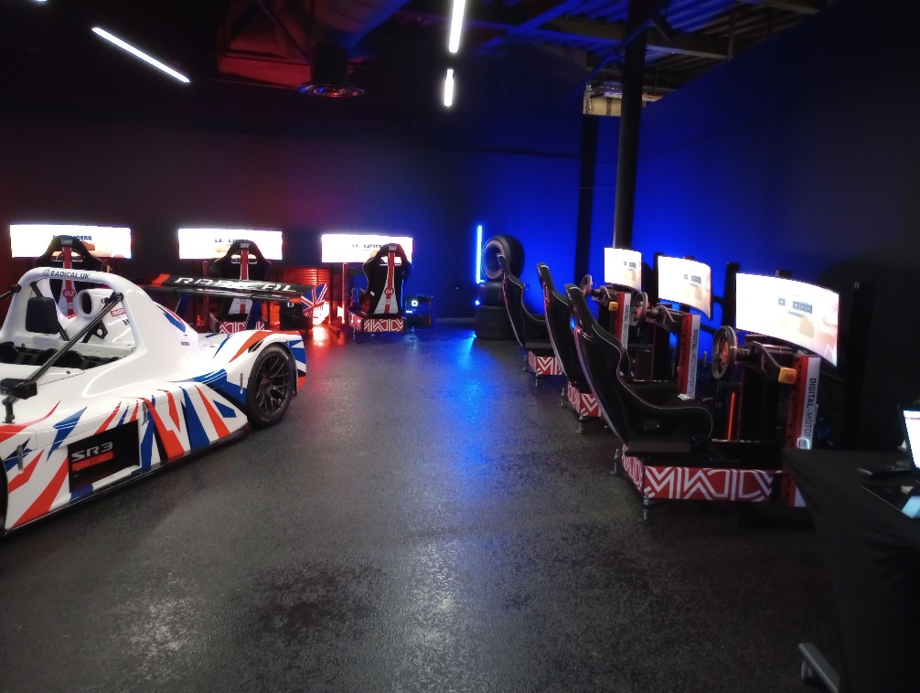
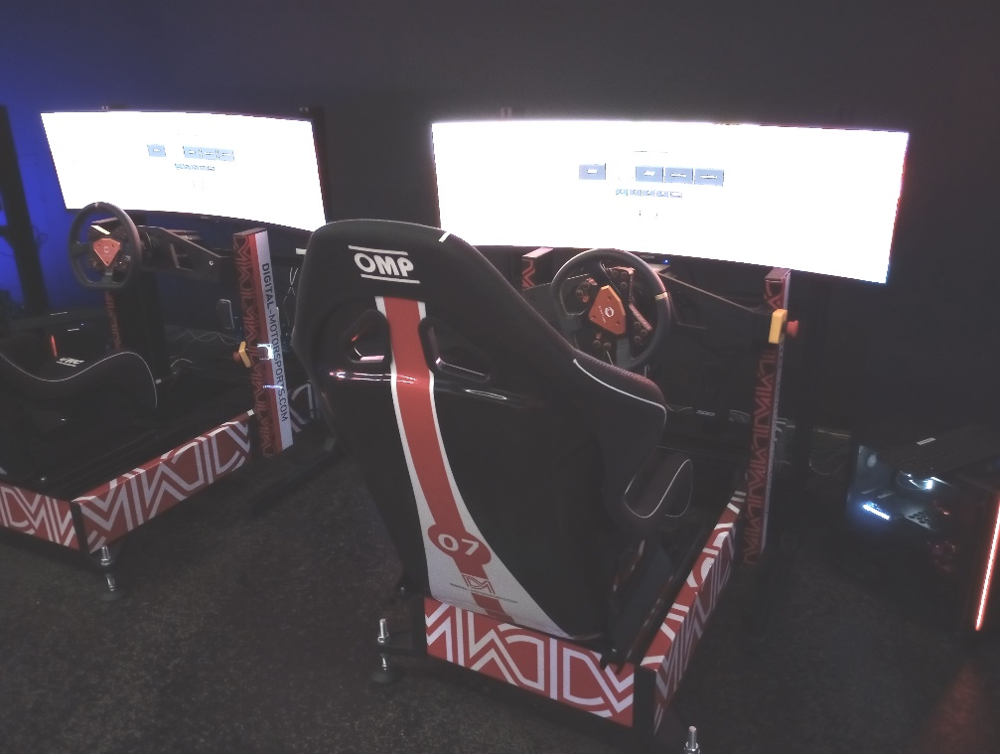

11 -The Ultimate Lap
You will sit in our special-effects cinema and watch as some of the circuits most iconic and dramatic moments happen around you on the Ultimate Lap of Silverstone. It’s not too loud but it does feel as if you as moving in the seat, as if you are in a car going around the track.
As with The Grid at the beginning of the exhibition, there is an option for visitors to exit after entering or walk past this phase of the exhibition. Please ask one of the welcome team to direct you if necessary.
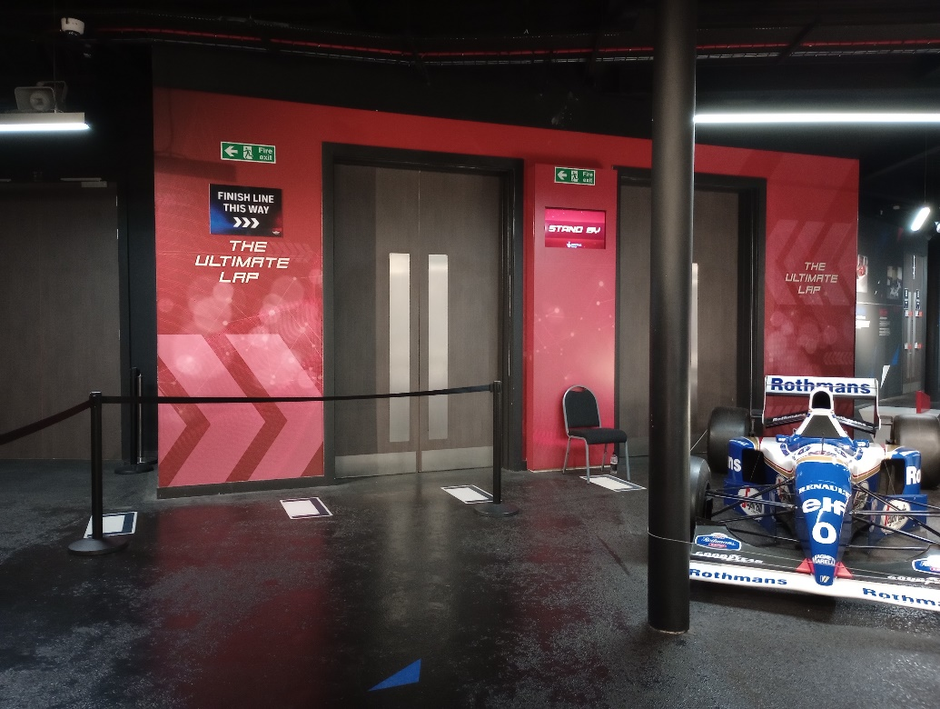
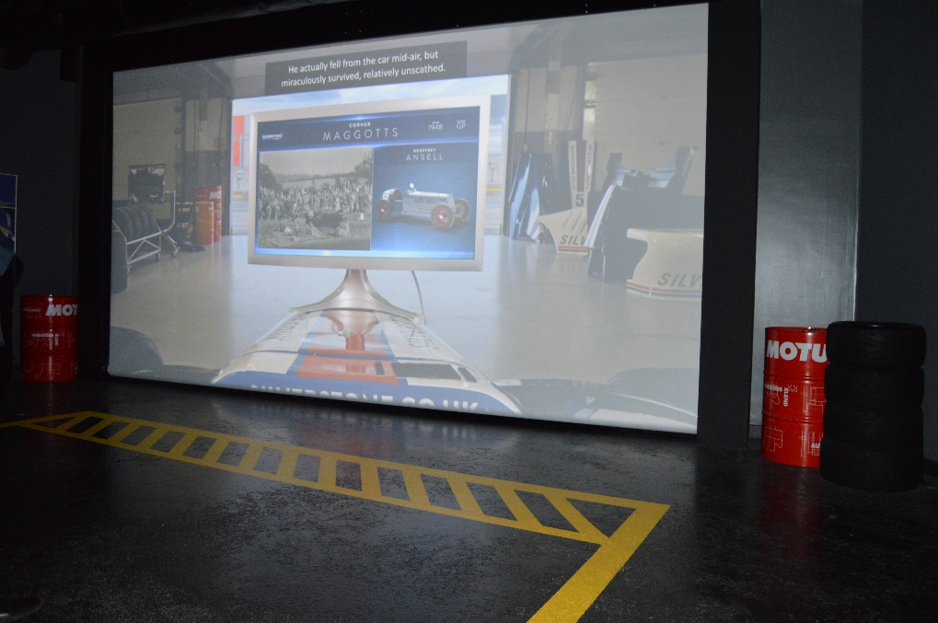
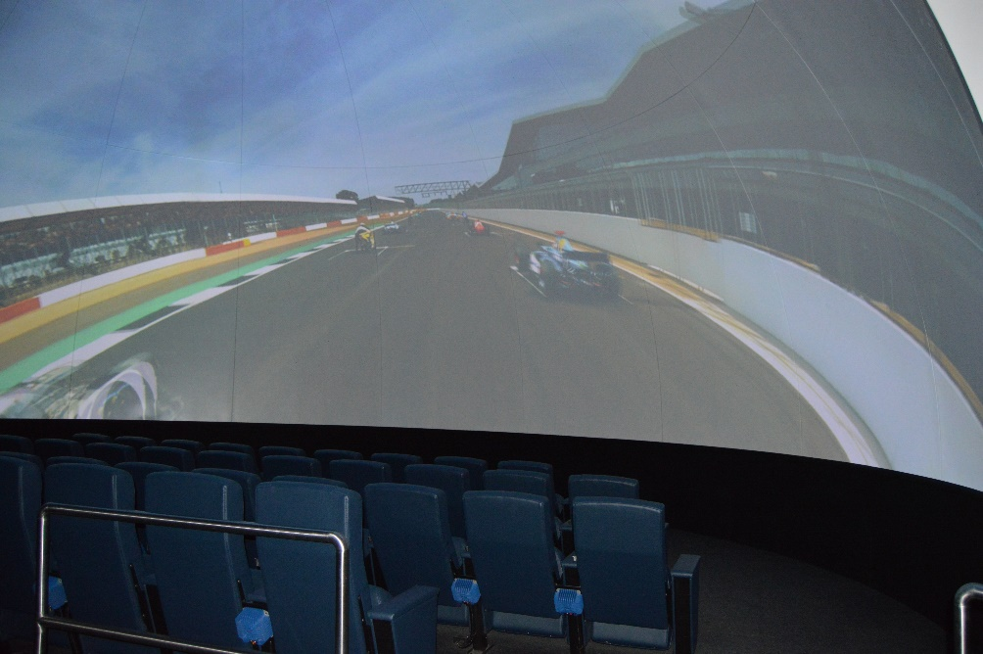

12 – Café and Shop
As you exit the Ultimate lap you will enter the museum shop. A bespoke range of merchandise is available from the shop, including products inspired by the archive and pocket-money treats, as well as Silverstone Circuit branded products.
The cafe is open from 10am until 4pm. Because of our unique collection of cars, motorbikes and memorabilia no food or drink can be taken in the exhibition.
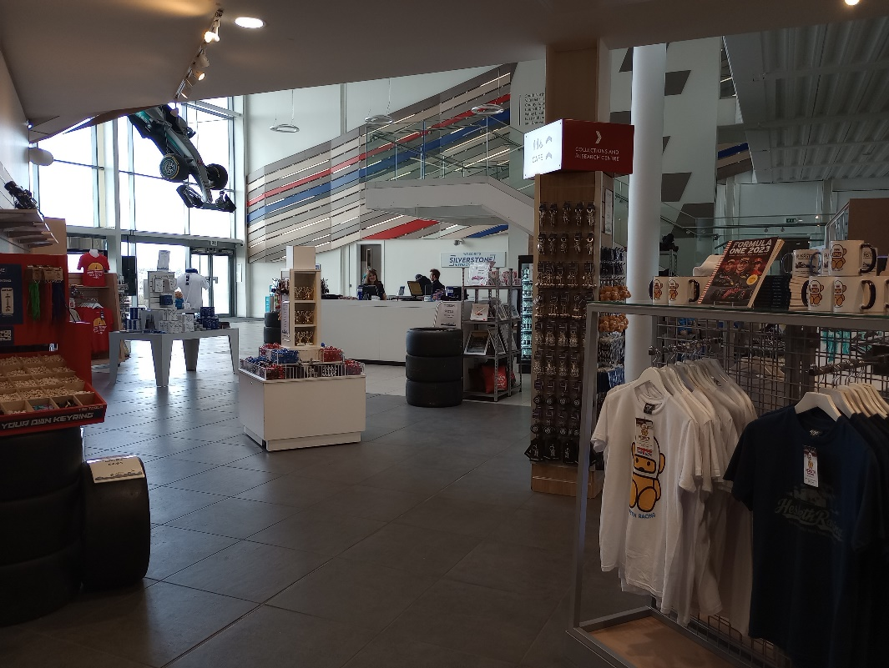
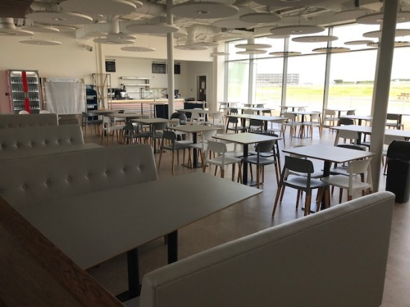

13 – Heritage track trail
The doors next to the Café give you the opportunity to head out onto our outdoor Heritage Track Trail. The member of our team will ask to see your wristband. Be careful as you cross the road as cars pass here regularly. Outside you can walk on the old track itself, from Bridge corner to Priory. Take a photograph with the Sir Lewis Hamilton mural if you wish
This area can also be used for you to have lunch (if the weather permits). You will be able to see any track-based activity going on during you visit (this cannot be guaranteed) and use the space to have some outdoor time.
Please note that due to circuit activity and adverse weather the Heritage Track Trail will not be open 365 days a year, so please check in advance of booking if you would like to go on this walk.
You can get a great view of the race track from Luffield Terrace, there are two ramps that you can use, one is designed for those in wheelchairs. If it’s a nice day you can even take your lunch out here!
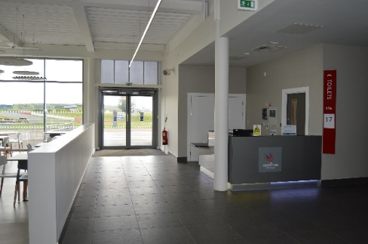
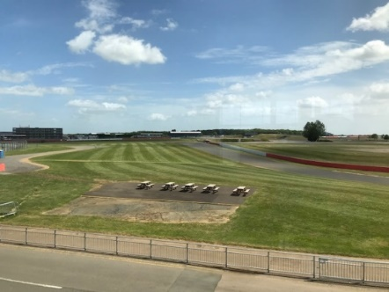

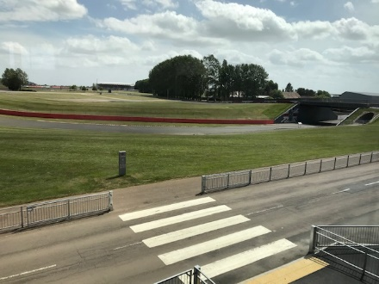
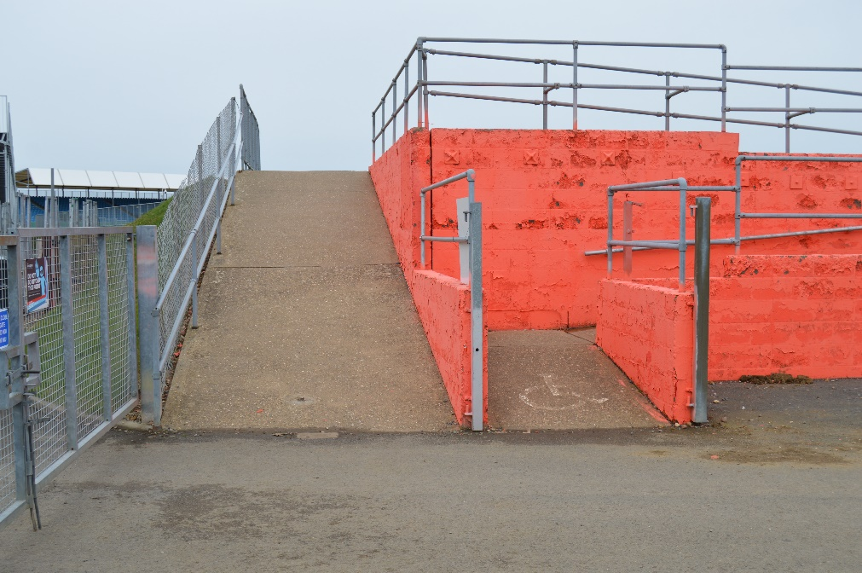
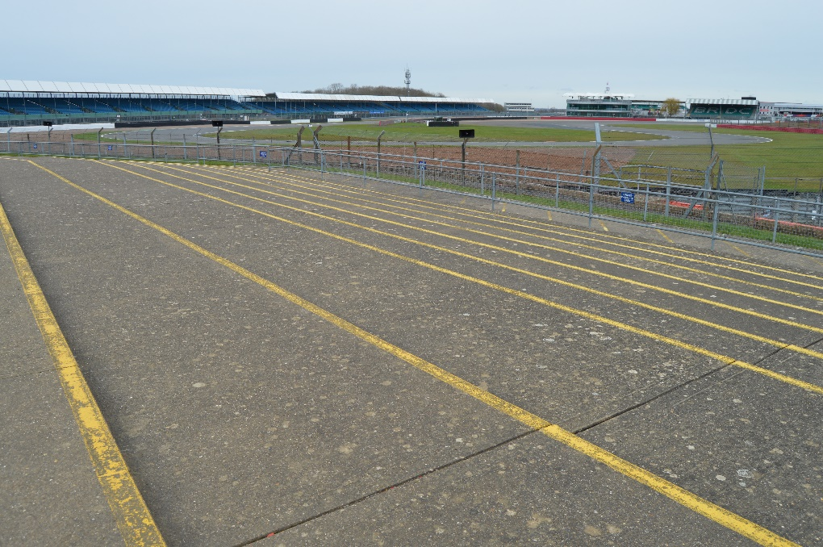
14- Silverstone Circuit Scalextric track
On the upper level of the museum, just after you exit the gird, is a Scalextric track of Silverstone Circuit. You may choose to participate in a few laps of the Scalextric track, battling others for the fastest lap and the win.
During busier times you may need to queue for your turn here, but the queue normally moves quite quickly.
